Sentiment Analysis of Smartphone Tweets Using Machine Learning
1. Introduction
Sentiment analysis is a Natural Language Processing (NLP) technique used to classify text into emotional categories such as positive, negative, or neutral. In this project, sentiment analysis is applied to tweets related to smartphones.
The objective is to compare the performance of three machine learning algorithms:
- Naïve Bayes
- Logistic Regression
- Support Vector Machine (SVM)
and evaluate which model performs best for tweet sentiment classification.

2. Dataset Description
The dataset consists of 100 manually labeled tweets about smartphones.
Columns:
- Tweets: Text content of tweets
- Sentiment: Label (Positive / Negative / Neutral)
Data Split:
- Training set: 80%
- Test set: 20%

3. Data Preprocessing
The following preprocessing steps were applied:
- Converted text to lowercase
- Removed URLs
- Removed punctuation and special characters
- Cleaned unnecessary whitespace
After preprocessing, text data was converted into numerical format using TF-IDF (Term Frequency–Inverse Document Frequency).

4. Exploratory Data Analysis (EDA)
Sentiment Distribution
The dataset distribution is shown below:
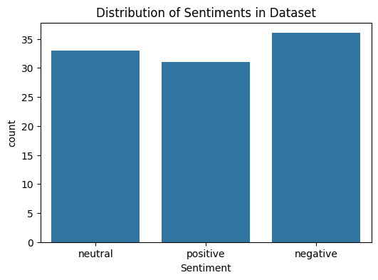
Observation:
- The dataset is relatively balanced across positive, negative, and neutral classes.
- This helps reduce bias during training.

5. Model Training
Three machine learning models were trained:
- Naïve Bayes
- Logistic Regression
- Support Vector Machine (SVM)
All models used TF-IDF features from the tweet text.

6. Model Evaluation
Models were evaluated using:
- Accuracy
- Precision
- Recall
- F1-score

7. Results and Visualizations
7.1 Accuracy Comparison
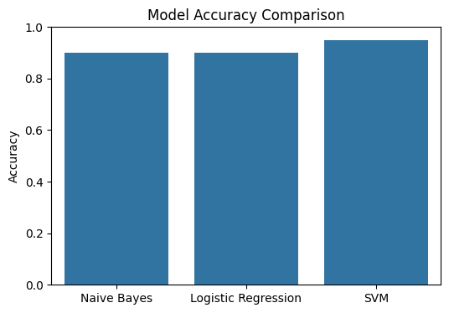
Model | Accuracy
Naïve Bayes | 0.90
Logistic Regression | 0.90
SVM | 0.95

Observation:
- SVM achieved the highest accuracy.
- Naïve Bayes and Logistic Regression performed similarly.

7.2 F1 – Score Comparison
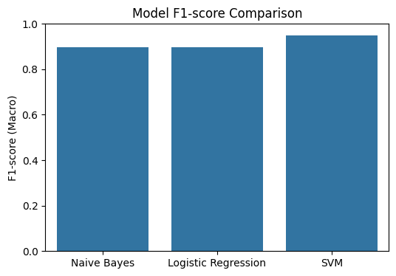

Model | F1-score (Macro Avg)
Naïve Bayes | 0.90
Logistic Regression | 0.90
SVM | 0.95

Observation:
- SVM shows the best balance between precision and recall.
- It handles all sentiment classes more effectively.

7.3 Confusion Matrix (SVM)

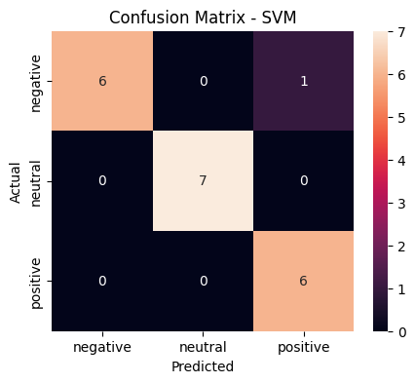
Observation:
- Most predictions are correct along the diagonal.
- Very few misclassifications occur.
- Neutral class is classified perfectly in most cases.

8. Discussion
The results show that all models perform well on sentiment classification of smartphone tweets. However, Support Vector Machine (SVM) outperforms the others due to its effectiveness in handling high-dimensional sparse data generated by TF-IDF.
Naïve Bayes and Logistic Regression show similar performance, indicating that linear and probabilistic assumptions perform comparably on this dataset.

9. Conclusion
This study compared three machine learning models for sentiment analysis of smartphone-related tweets. The SVM model achieved the best performance with:
- Highest accuracy: 95%
- Highest F1-score: 0.95
Thus, SVM is the most suitable model for this dataset.

10. Limitations and Future Work
Limitations:
- Small dataset size (100 tweets)
- Limited diversity in language
- Possible bias due to manual labeling
Future Improvements:
- Use larger datasets
- Apply deep learning models (LSTM, BERT)
- Perform cross-validation for more robust evaluation
- Use word embeddings instead of TF-IDF

11. Conclusion
This project demonstrates that traditional machine learning models, especially SVM, are highly effective for sentiment classification tasks even with small datasets when combined with proper text preprocessing and TF-IDF feature extraction.

